NAME: Tiya Shah SAP ID : 60019230111

NAME: Riya Vaghasiya SAP ID: 60019230090

NAME: Prisha Furia SAP ID: 60019230093

NAME: Rujuta Mumbarkar SAP ID: 60019230068

Title

ESP32-Based Web Server for Real-Time Environmental Analysis: Integrating Derived Metrics (Heat Index and Dew Point) 🔬

Connecting Diagram (Workflow)

The diagram below illustrates the data flow, from physical environment to final browser output, highlighting the roles of the hardware, firmware, and client interface.

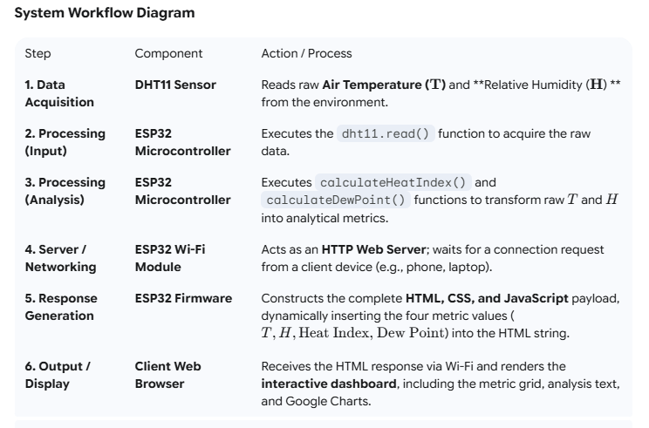

Work Done

The core work involved extending a basic sensor-reading program into a robust, analytical, and well-presented application, primarily through code refactoring and the implementation of mathematical models.

1. Mathematical Analysis & Derived Metrics

The most critical work was implementing the logic to generate useful, secondary data metrics from the two raw sensor inputs ($T$ and $H$).

Heat Index Implementation: A dedicated C++ function, calculateHeatIndex(T_c, H_p), was created to calculate the 'feels like' temperature, providing an indicator of thermal stress that is more relevant to human comfort than simple air temperature.

Dew Point Implementation: A dedicated C++ function, calculateDewPoint(T_c, H_p), was implemented using the Magnus-Tetens approximation formula. This shows the absolute moisture content, which is vital for predicting fog, condensation, or managing moisture-sensitive applications (e.g., agriculture and storage).

2. Advanced Web Dashboard Development

Significant effort was placed into improving the client interface to elevate the project's presentation quality.

Dynamic HTML Structure: The response structure was heavily modified to include distinct sections for Raw Data, Derived Metrics, and Analysis/Interpretation.

CSS Styling: Custom CSS was added to create a clean, modern Metric Grid, using different background colors (#ffe5e5 for Heat Index, #e0f7fa for Dew Point) to distinguish the analytical metrics from the raw data.

Contextual Analysis: A dedicated analysis section was added to interpret the calculated metrics and provide real-world application context, including the added Crop Health Quote, which ties the environmental data directly to a practical field of study.

3. Code Refactoring and Modularity

The final code separates the application logic from the presentation layer:

Logic Isolation: The complex mathematical formulas for Heat Index and Dew Point were moved into separate, reusable C++ functions outside of the main loop(), improving readability and maintenance.

In-Place HTML Injection: All calculated float values were converted to String objects (e.g., String(heatIndex_c, 1)) and injected directly into the HTML string being generated, ensuring the browser always displays the very latest, processed data.

